| Test 2, Version A | |
| --- | --- |
| Course Information: Phys 2A | Instructor Name: John R. Walkup |

***d*** = ***v***o*t* + (1/2)***a****t*2 ***v*** = ***v***o + ***a****t*  ***F***net = *m****a*** ***F***g = *m***g** *F*fr ≤ s*N*  *F*fr = k*N P =* *W/**t = Fv*

Use *g* = 10 m/s2 *WC = –*PE *WNC =* E *Wnet =* 😐E *W* = *Fd*cos     😐  *mv*2 PE = *mgh*

*s* = *r* *v* = r a = r *a*c = *v*2/*r* net = *I*   = o + *t*  = o*t* + (1/2)*t*2 *W  Fd*cos**

### Multiple-Choice Questions

1. According to the way we do things in this class, the key to solving equations involving forces and Newton’s second law is to:
2. First draw a picture of the system
3. Find the acceleration of the system
4. Find the least-action of the system
5. Draw a free-body diagram of the system
6. Work done by a nonconservative force on an object always
7. Increases the total energy of the object
8. Decreases the potential energy of the object
9. Decreases the total energy of the object
10. Increases the potential energy of the object
11. Both (a) and (b)
12. An elevator descends at a constant velocity. Which of the following is true?
13. The total energy of the elevator is conserved because no net external force acts on the elevator.
14. The total energy of the elevator is conserved because energy is always conserved.
15. The total energy of the elevator is not conserved because a net external force acts on the elevator.
16. The total energy of the elevator is not conserved because a non-conservative force does work on the elevator.
17. Moved to Free Response. Choose option (a) on your Scantron if you are using one.
18. A mechanic pushes a 3200-kg car from rest to a speed of *v*, doing 5,040 J of work in the process. During this time, the car moves 29.0 m. Neglecting friction between car and road, find the horizontal force exerted on the car.
19. 290 N
20. 174 N
21. 230 N
22. 410 N
23. 340 N
24. 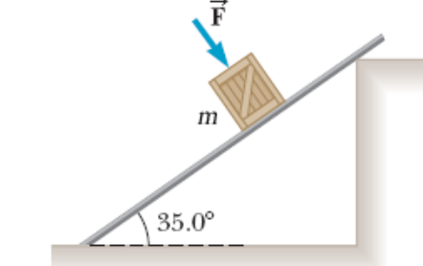The coefficient of static friction between the *m* = 2.95−kg crate and the 35.0° incline of the figure below is 0.295. What minimum force *F* must be applied to the crate perpendicular to the incline to prevent the crate from sliding down the incline?
25. 56 N
26. 23 N
27. 11 N
28. 39 N
29. 33 N

NOTE: For the above problem, show your work. Without it, you will not be credited.

1. 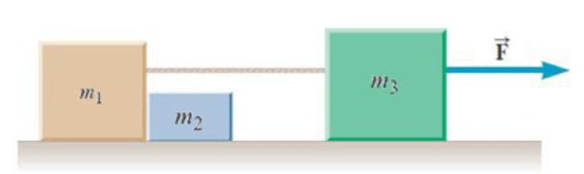Assume the three blocks (*m*1 = 1.0 kg, *m*2 = 2.0 kg, and *m*3 = 3.5 kg) portrayed in the figure below move on a frictionless surface and a force F = 34 N acts as shown on the 3.5-kg block. Determine the force exerted on the 1.0-kg block by the 2.0-kg block. (Pick the closest answer.)
2. 10.5 N
3. 8.8 N
4. 3.2 N
5. 23.0 N
6. 5.8 N

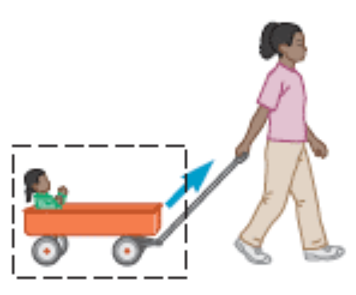

1. The wagon exerts a force... (Choose ALL that apply.)
2. downward on the Earth due to contact
3. upward on the Earth due to contact
4. upward on the Earth due to gravitational attraction
5. downward on the Earth due to gravitational attraction
6. downward to the left on the handle
7. A boy throws a baseball onto a roof and it rolls back down and off the roof with a speed of 4.55 m/s. If the roof is pitched at 32.0° below the horizon and the roof edge is 2.90 m above the ground, find the time the baseball spends in the air.
8. 0.242 s
9. 0.562 s
10. 0.731 s
11. 0.663 s
12. 0.165 s
13. Our course textbook has a mass of 0.50 kilograms. I lower this textbook down 2.2 meters at a constant velocity of 3 m/s. How much work do I do on the textbook? (Choose the value closest to the correct answer.)
14. – 1.0 joules
15. 33 joules
16. 10.4 joules
17. – 10.4 joules
18. 0
19. Power is defined as
20. The amount of force that an object can impart on another
21. The overall work done over a a certain time duration
22. The rate at which work is done
23. The pressure applied to an object during a collision
24. The impulse imparted by an object performing work on another.

### Name: __________________________

### Show All Work and Circle Your Answer

1. 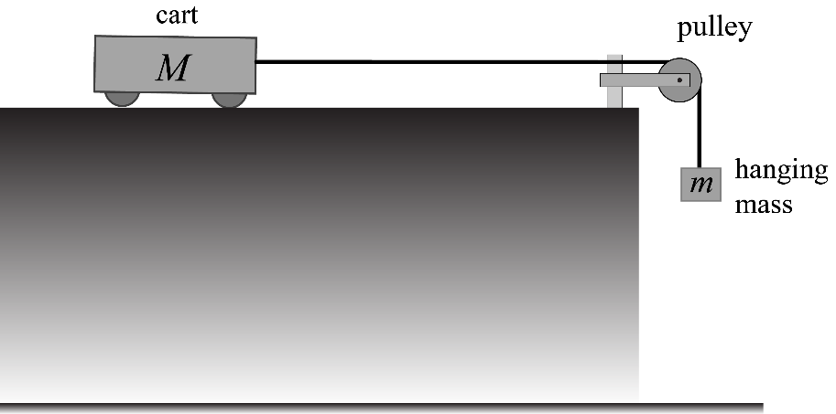In the figure, *M* = 12 kg. Mass *m* is at a height *H* = 3 meters above the ground. There is no friction. Suppose it takes 2 seconds for mass m to reach the ground
2. What is the value of *m*?
3. How fast will it be traveling right before it hits the ground?
4. How much tension is in the string as *m* descends?
5. How fast will it be traveling right before it hits the ground if the surface is rough? (Assume k = 0.1; you can also assume that only kinetic friction applies)

*NOTE: You must show all work to receive credit for this problem. Do NOT simply write down a formula derived specifically for this problem.*

1. A block is resting on a horizontal surface. The mass of the block is 40 kg. The coefficient of static friction between the block and the surface is s = 0.3 and the coefficient of kinetic friction is k = 0.20. A man then decides to push on the block with 30 newtons of horizontal force.
2. What is the acceleration of the block? Explain.
3. Suppose the man pushes on the block with 200 newtons instead. What is the acceleration of the block? Explain.
4. A race car accelerates from rest. Because of this acceleration, an ornament of unknown mass hanging from the rear-view mirror forms an angle  = 30o with respect to the vertical, as shown.
5. Knowing this angle, how far does the dragster travel during the first 3 seconds of motion?

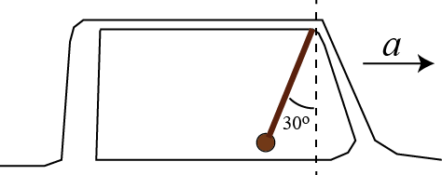

1. How fast will the race car be traveling at this point in time?
2. If the mass of the ornament is 2 kg, how much tension is in the string?

*NOTE: You must show all work to receive credit for this problem. Do NOT simply write down a formula derived specifically for this problem.*

1. A ball is launched at an initial speed of 100 m/s at an angle of 30o with respect to the horizontal. Three seconds after the ball is launched…
2. How fast is it traveling?
3. In which direction is it traveling?

1. How far is it from its starting point? (That is, what is the total distance from the launch point to the ball?)

1. A 300-kg motorcycle is traveling at 10 m/s. The driver notices a wreck ahead, applies the brakes. The motorcycle slides across the ground with a coefficient of kinetic friction **k = 0.3.
2. Using work-energy, find the distance it takes to stop the motorcycle.
3. Use work-energy to find the speed of the car 4 meters after the brakes are applied.